Event-Driven Agentic Document Workflows

<https://www.deeplearning.ai/short-courses/event-driven-agentic-document-workflows/>

Table of Contents

What are agentic document workflows? 1

Building a workflow 2

Adding RAG 10

Form parsing 14

Human in the loop 20

# What are agentic document workflows?

**RAG**: LLM does not train on your data. When giving LLM your data, the context window can only handle certain amount of data. The solution to that is to use RAG. **RAG stores knowledge externally, retrieves the most relevant parts on demand, and feeds those into the LLM — keeping everything efficient and scalable**. RAG is composed of retriever and generator.

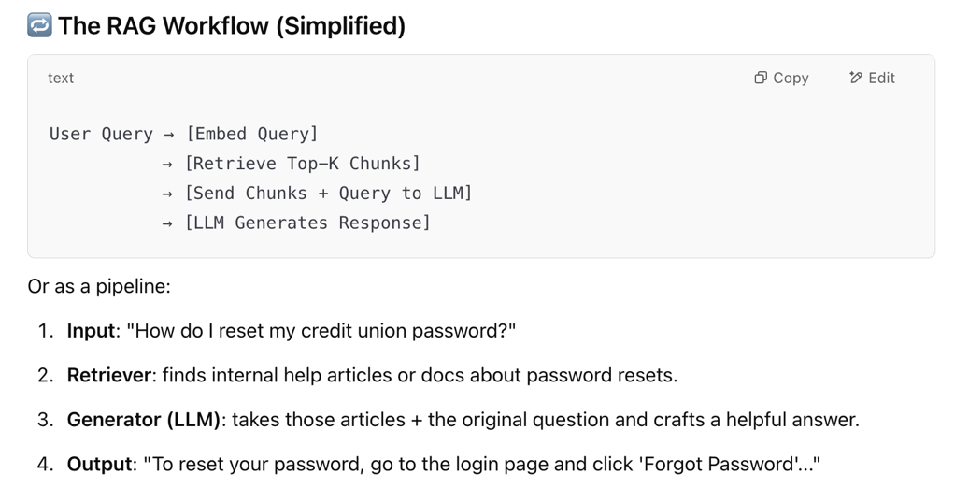

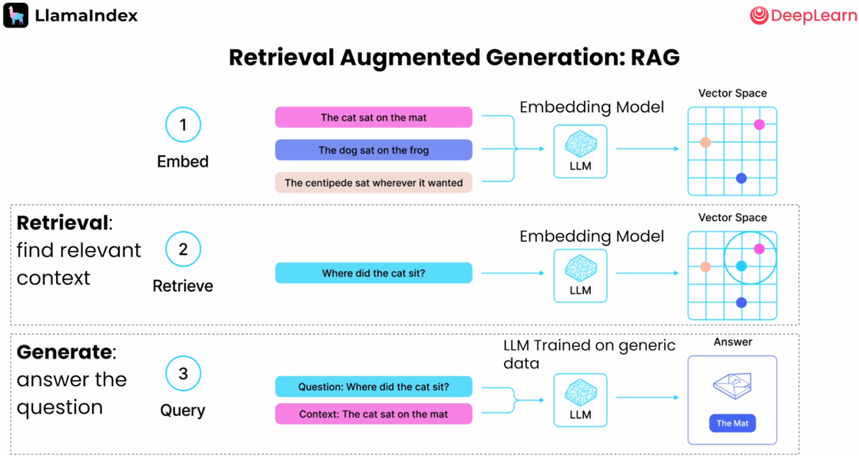

**Limitation of RAG**: RAG is based on search. If your question has multi-parts, then RAG will search your embeddings with a lot of things at once and the results RAG gets will be less focused.

Solution: split up your question to multiple simpler questions and glue the answers back together 🡪 build an agent

**What is an agent:**

* Semi-autonomous software
* Use tools
* Work towards a goal
* Non-deterministic

**What is a workflow:**

Workflow is an event-based system that provides structures to agents

# Building a workflow

Basic workflow:

Async: defines asynchronous functions, which can be paused and resumed, allowing other tasks to run in the same time.

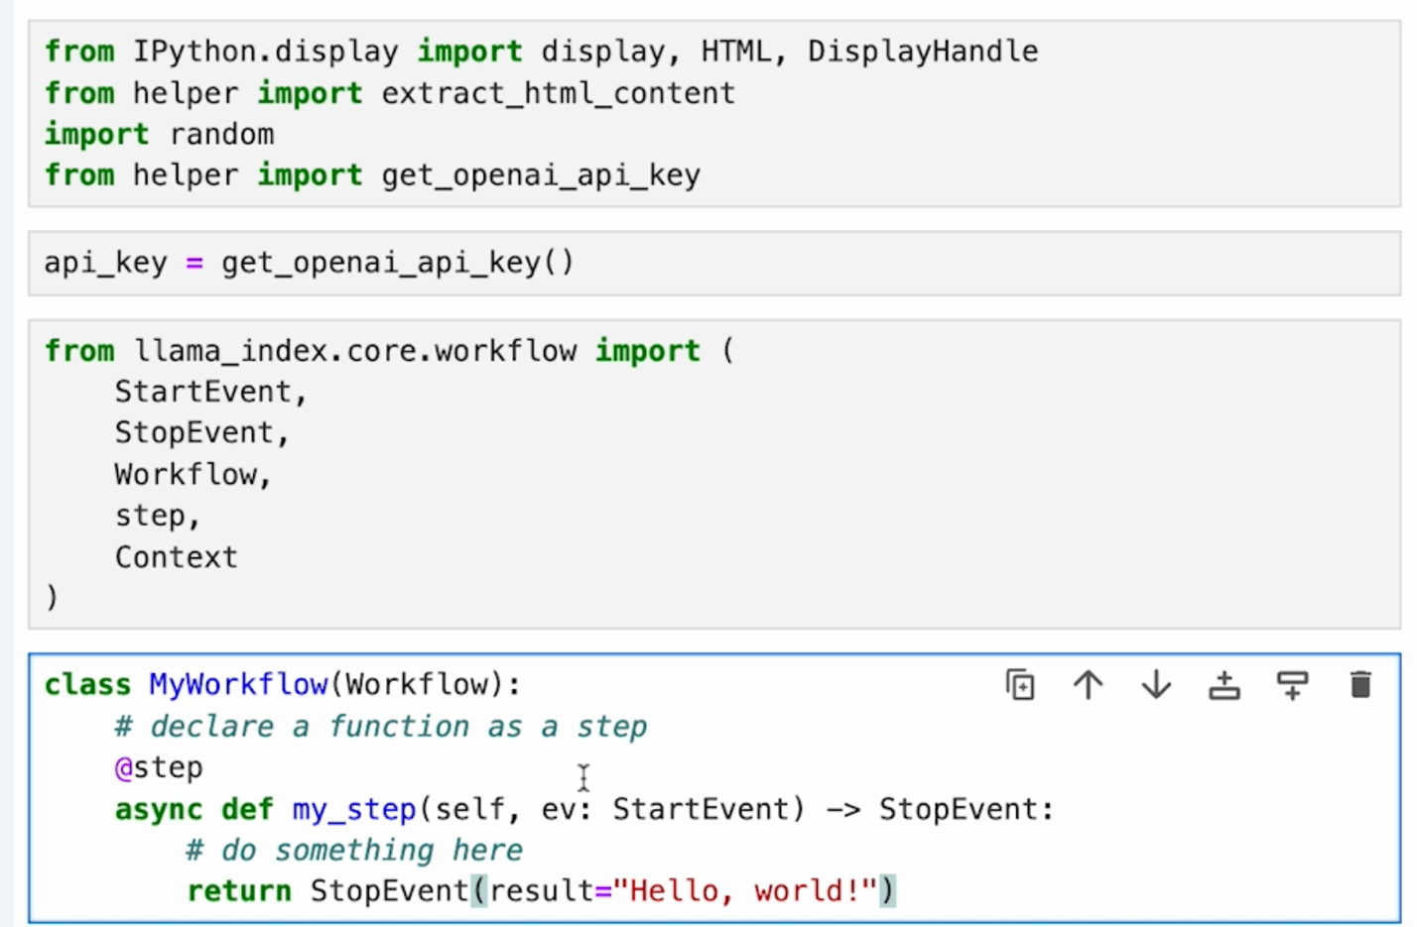

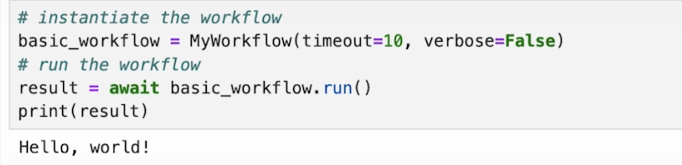

The code above is for notebook. The code below shows the same function but for vanilla python.

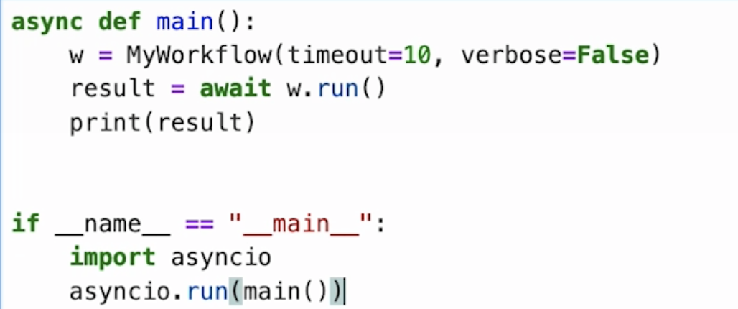

Example of loop event:

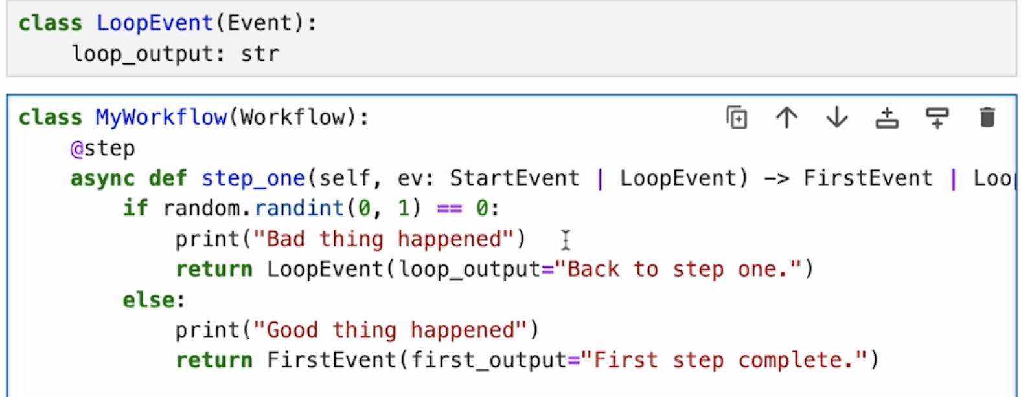

The result is random.

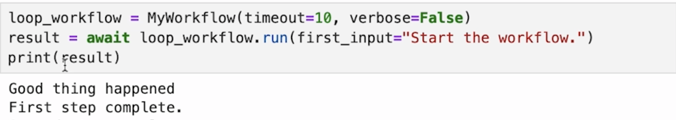

Example of a branch workflow:

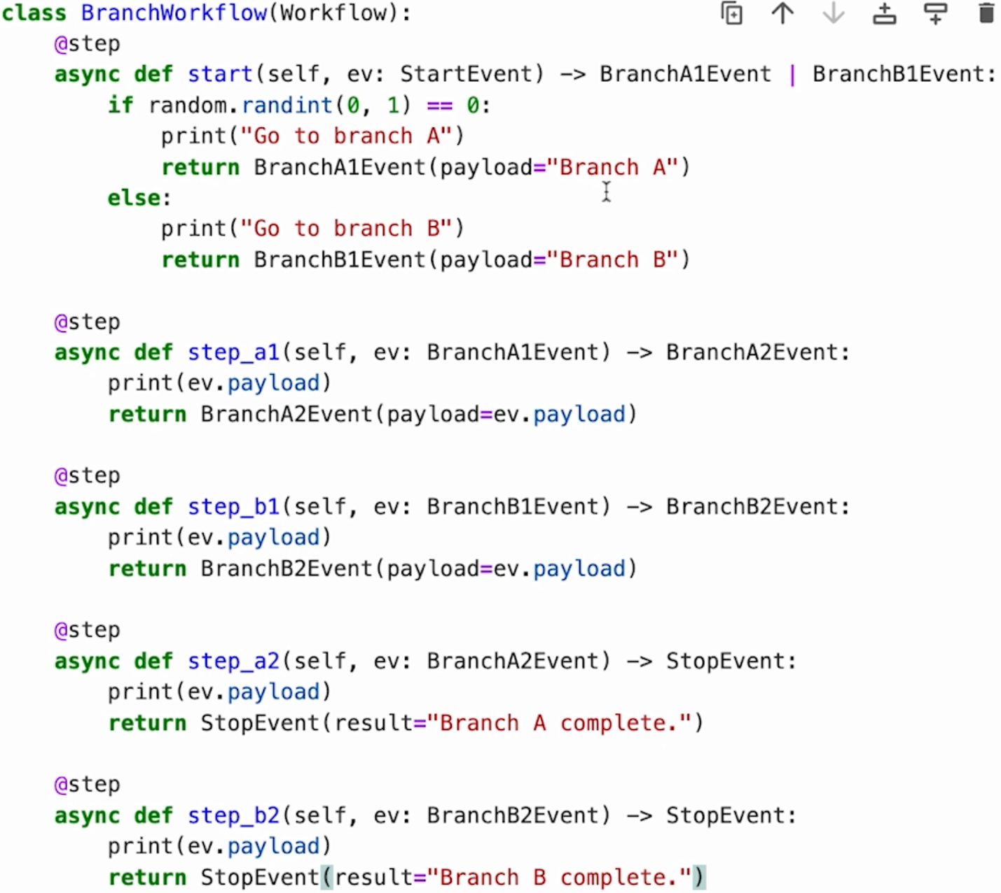

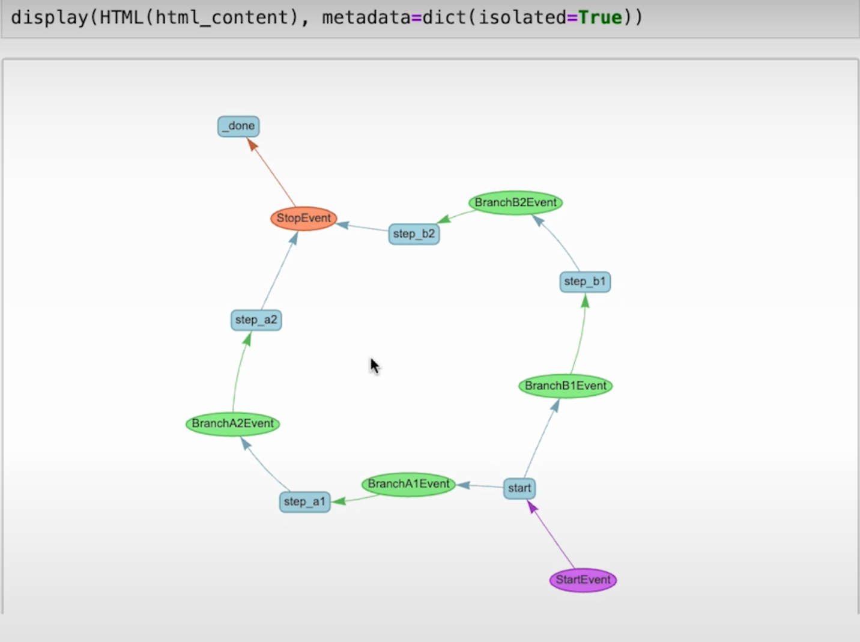

Example of a Concurrent workflow

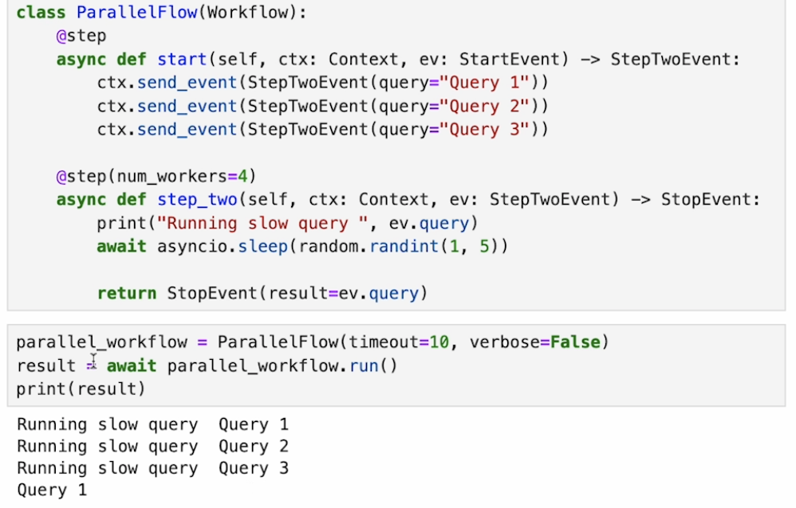

Collect events:

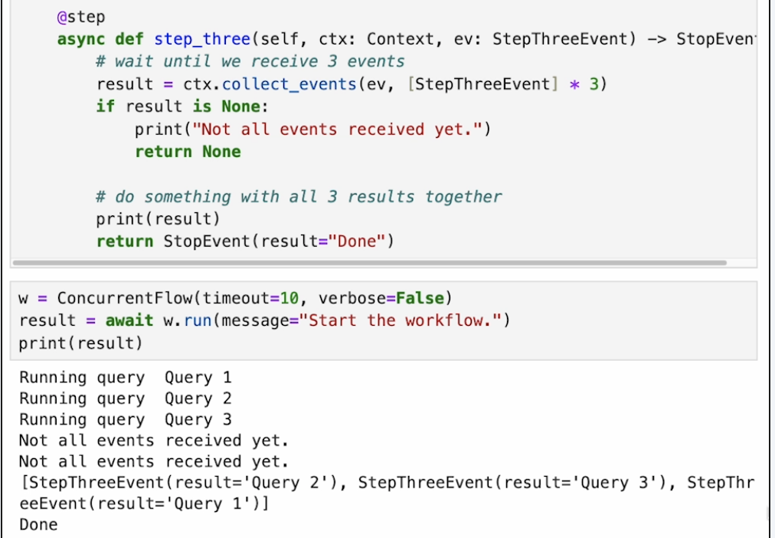

Example: Use LLM in the Workflows – when you ask LLM to generate a stream of responses, it will send back each chunk of its response as it becomes available. Step 1: say the progress is happening. Step 2: instantiate the LLM. Step 3: say the workflow is complete.

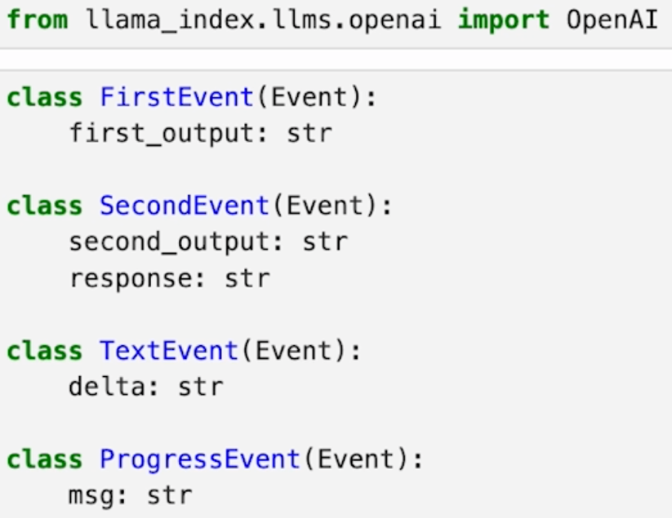

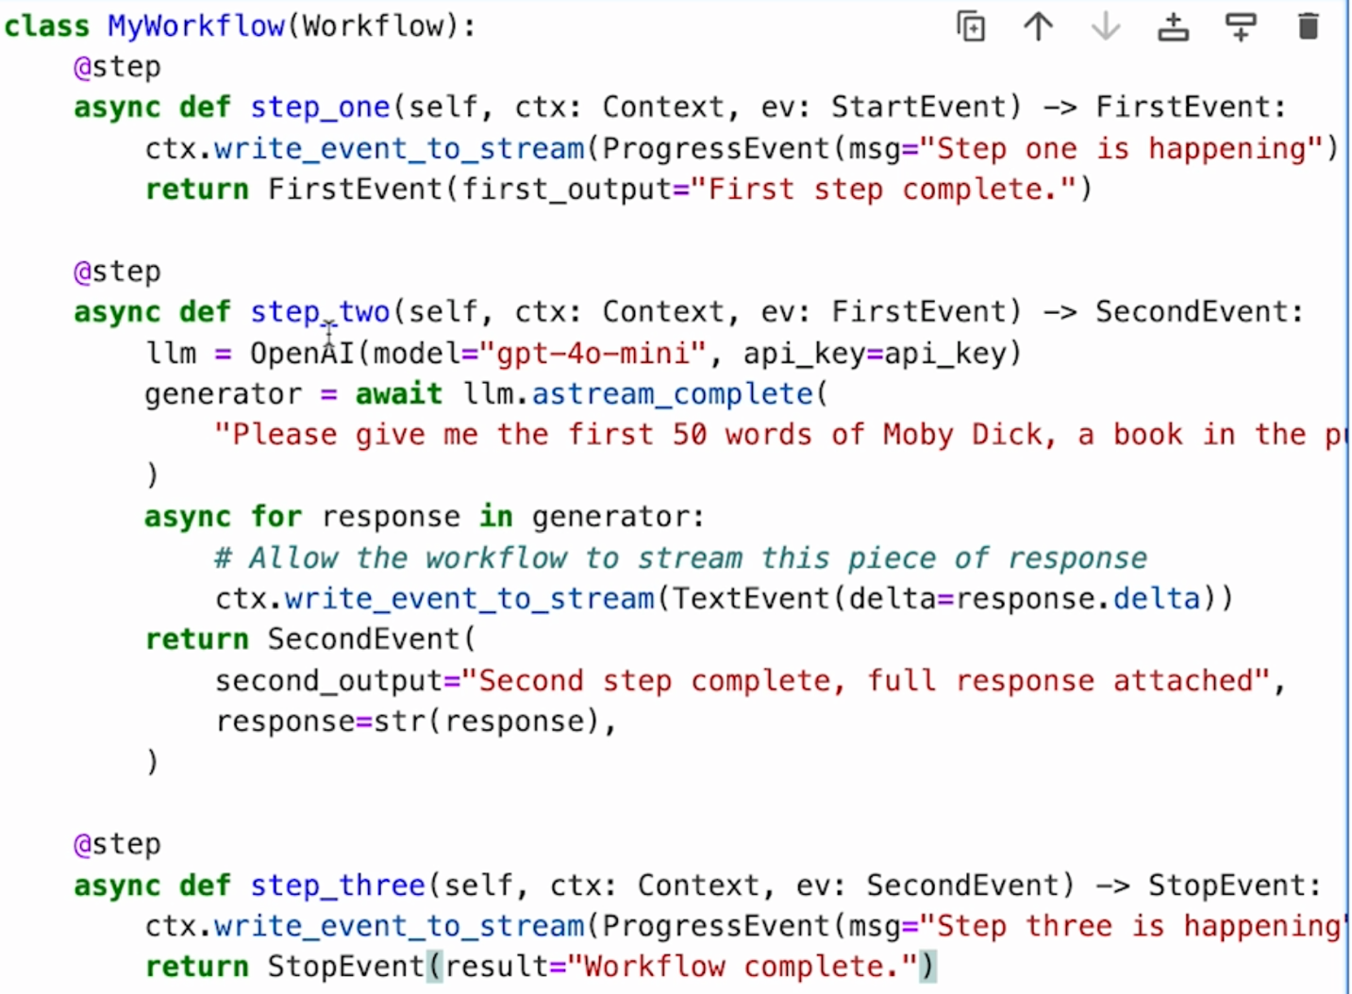

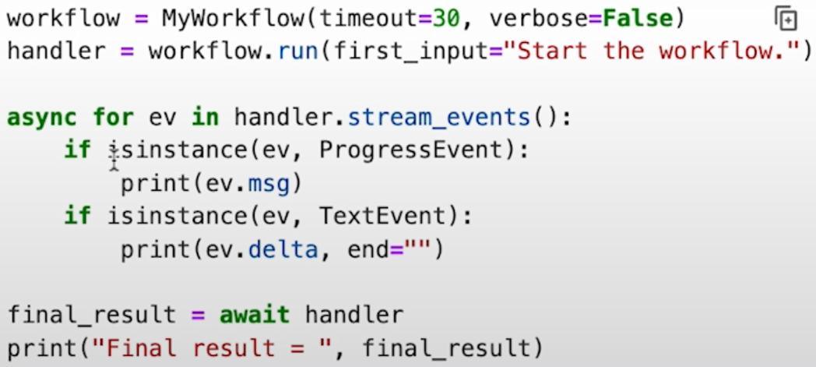

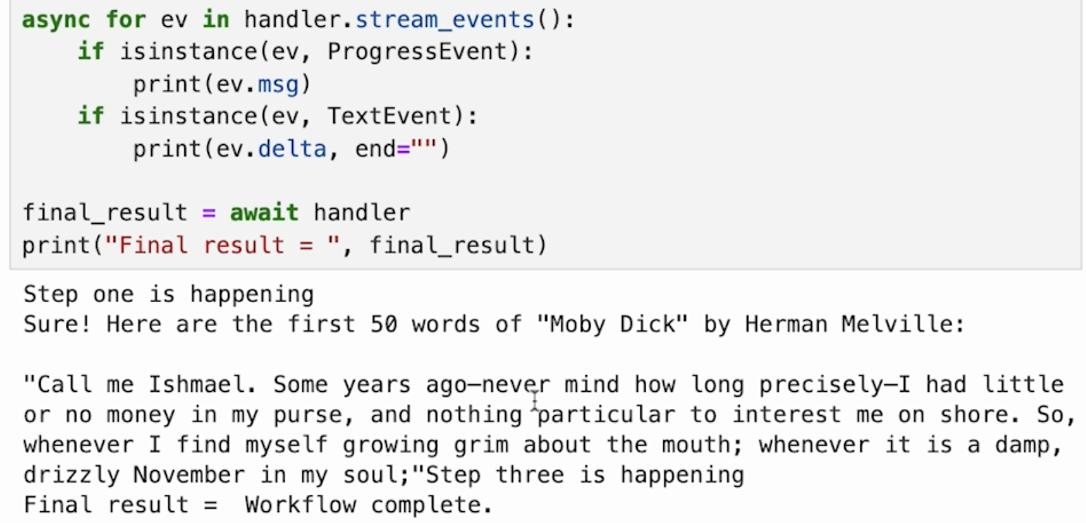

# Adding RAG

Use LlamaParse (advanced document parser that can read pdfs, word files, powerpoints, excel spreadsheets, etc.) to parse the resume 🡪 load the extracted information into a vector store 🡪 test it

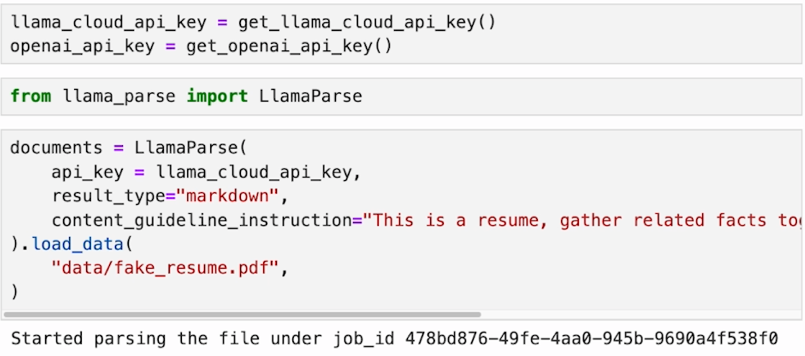

Use OpenAIEmbedding to embed the texts to vectors to be searched later

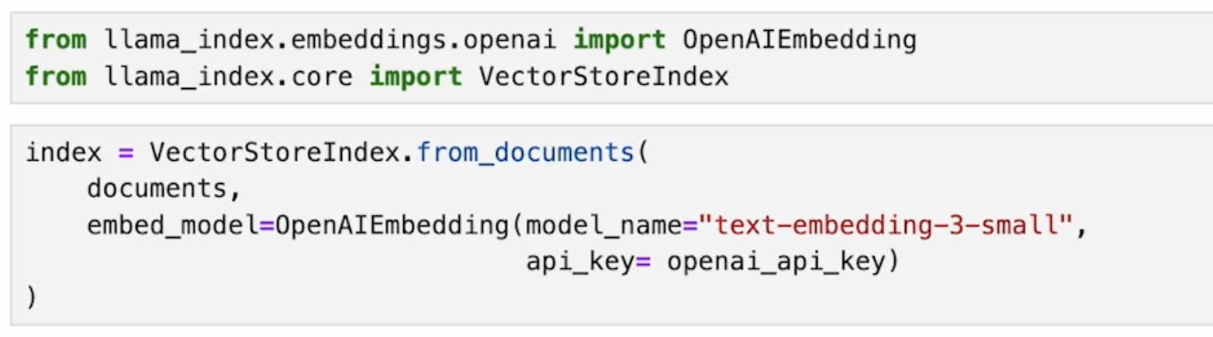

Use llm to get the response

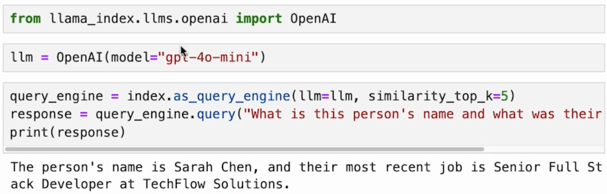

Store the vector stores so that we can use them later. Vector stores are easily persisted to disk.

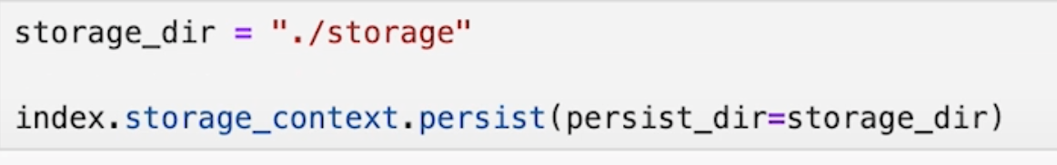

Check if the index is stored on disk and if we can query it

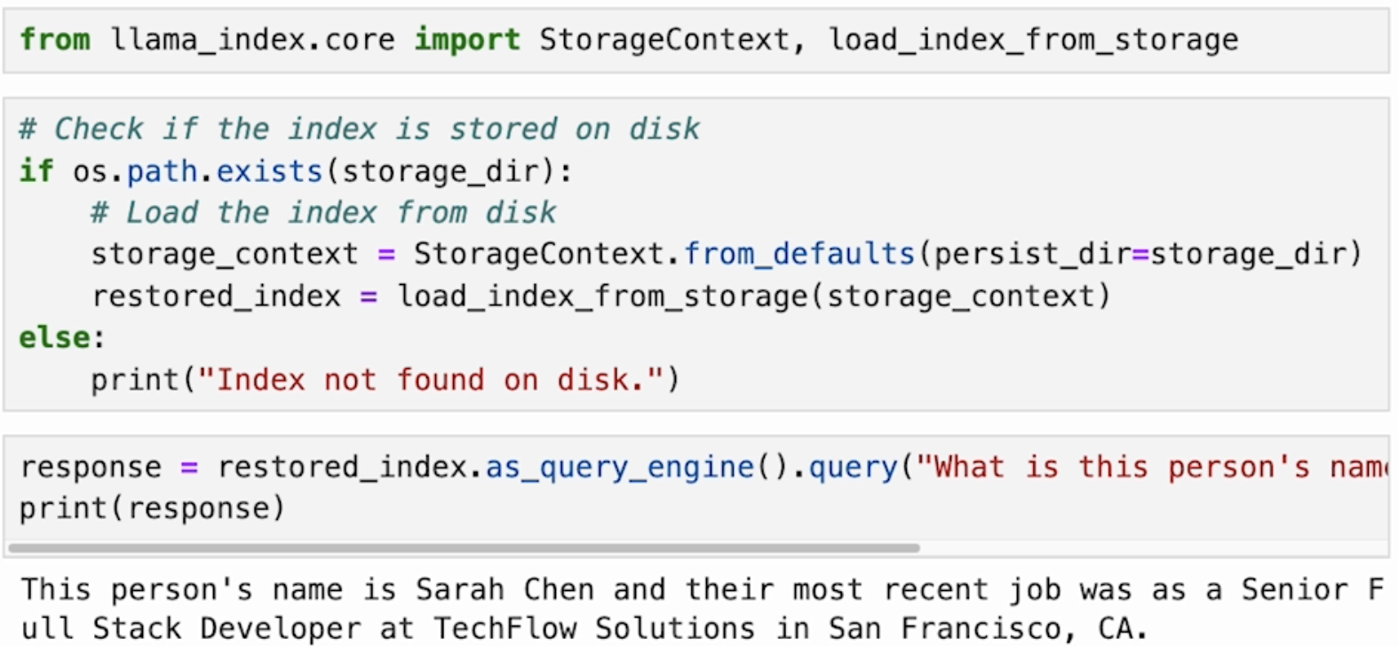

What we have done so far is RAG. Now, let’s turn RAG into a tool that can be used by an agent to answer questions. Step 1: create a python function that performs a RAG query. The framework will give all of this metadata to the LLM, the name, the types, and the docstring, and the LLM will use that metadata to decide whether or not this tool is useful and how to use this tool.

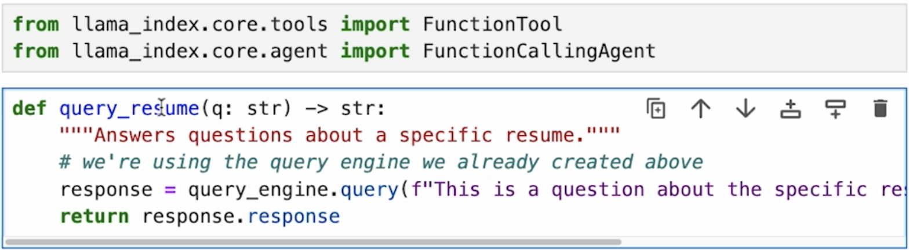

**Once we define this python function, we turn it into a tool that can be used by an agent using the from_defaults function**.



Then instantiate a function calling agent that uses this tool.

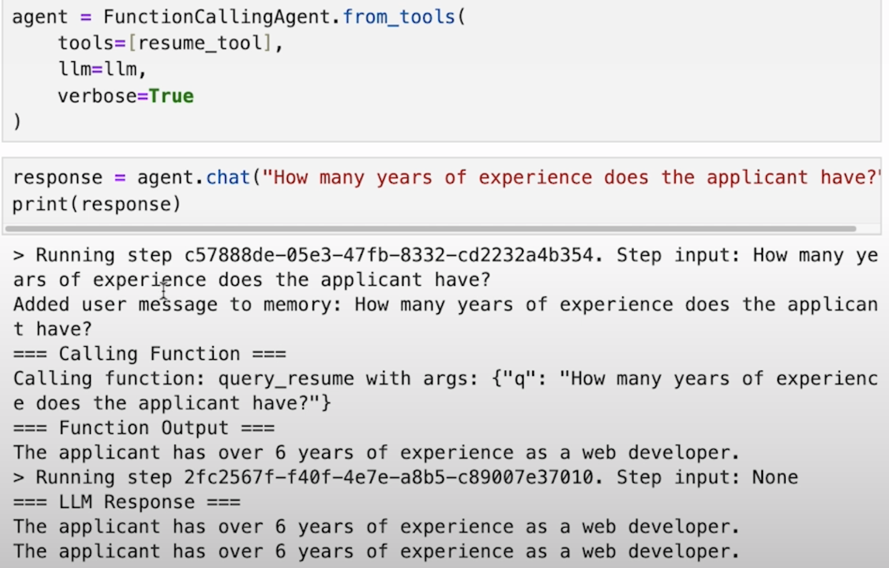

Create a RAG workflow

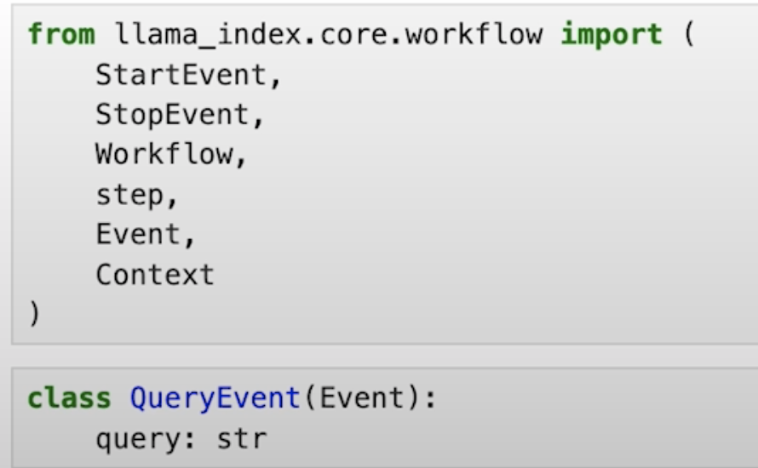

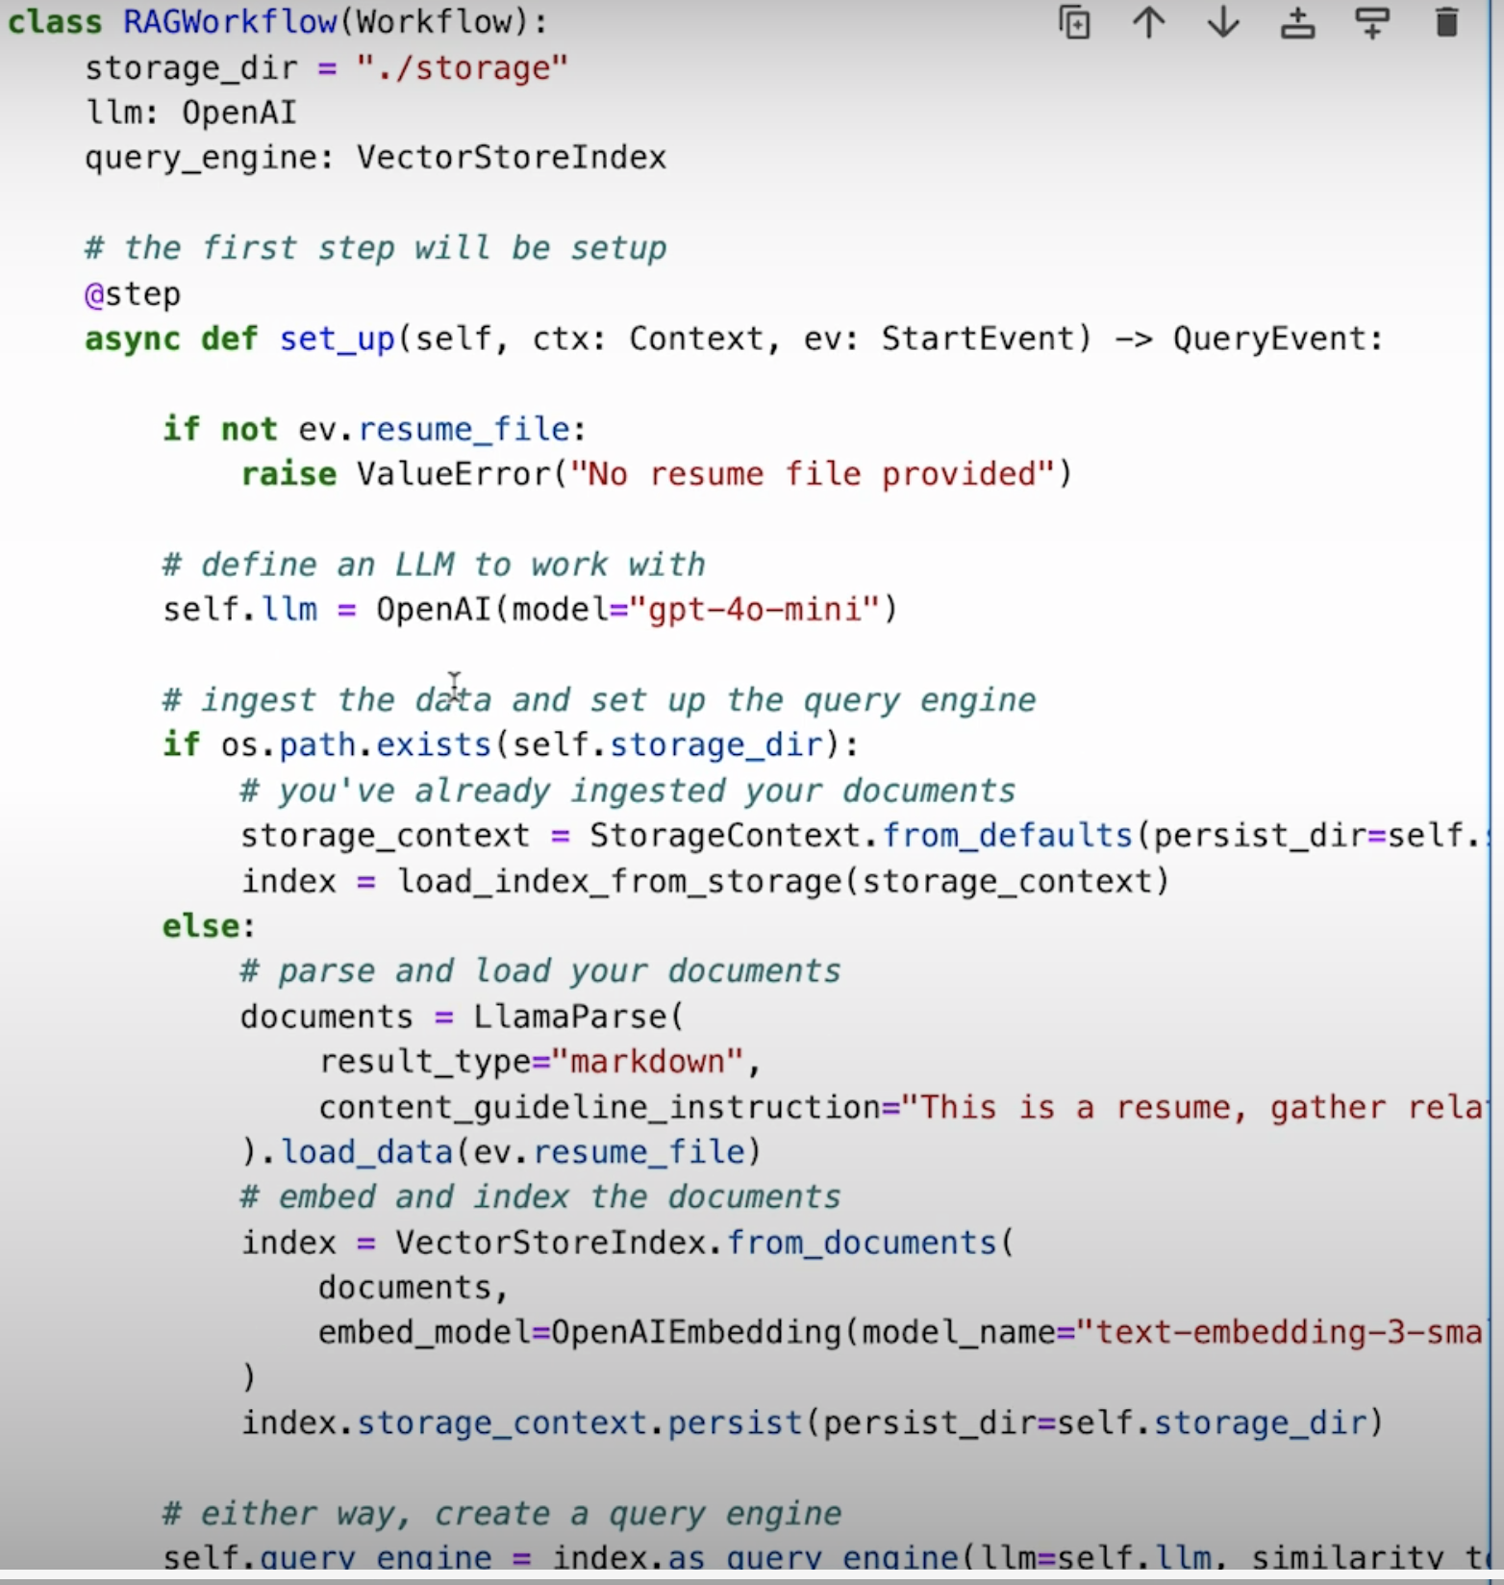

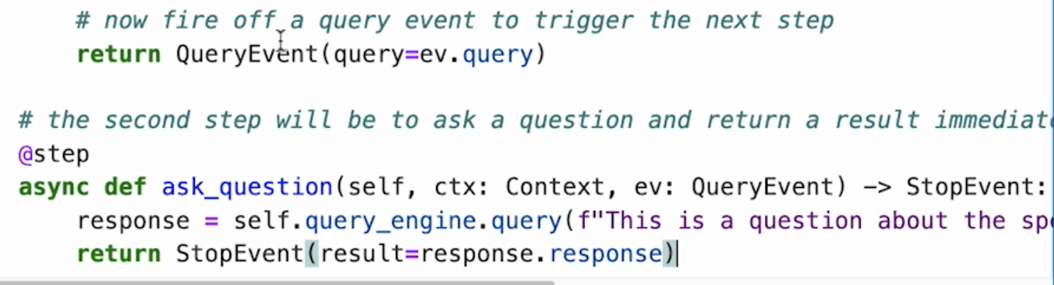

Run the workflow

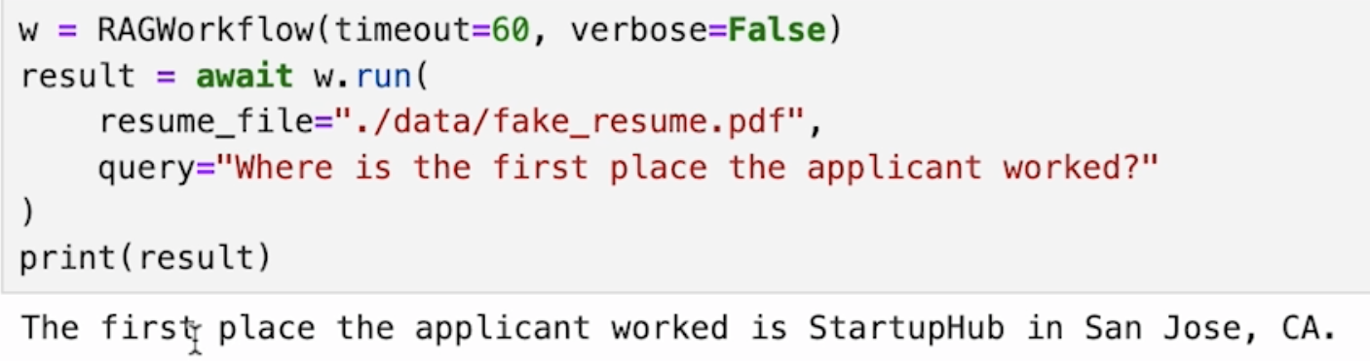

# Form parsing

Objective: Parse job application forms 🡪 convert the parsed form into a series of simple questions 🡪 use questions to query the RAG pipeline

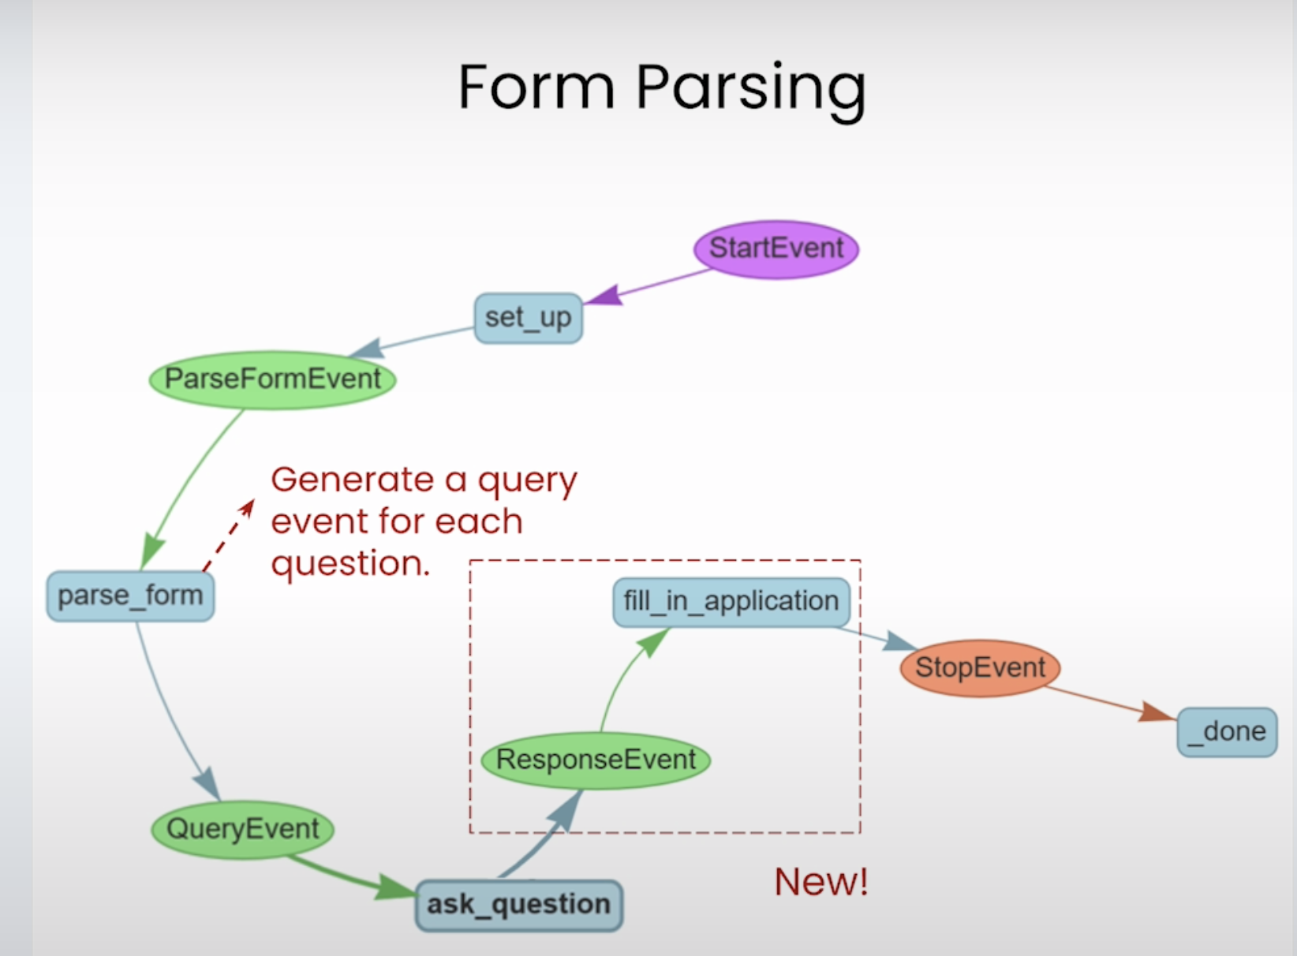

Step 1: Set up parser

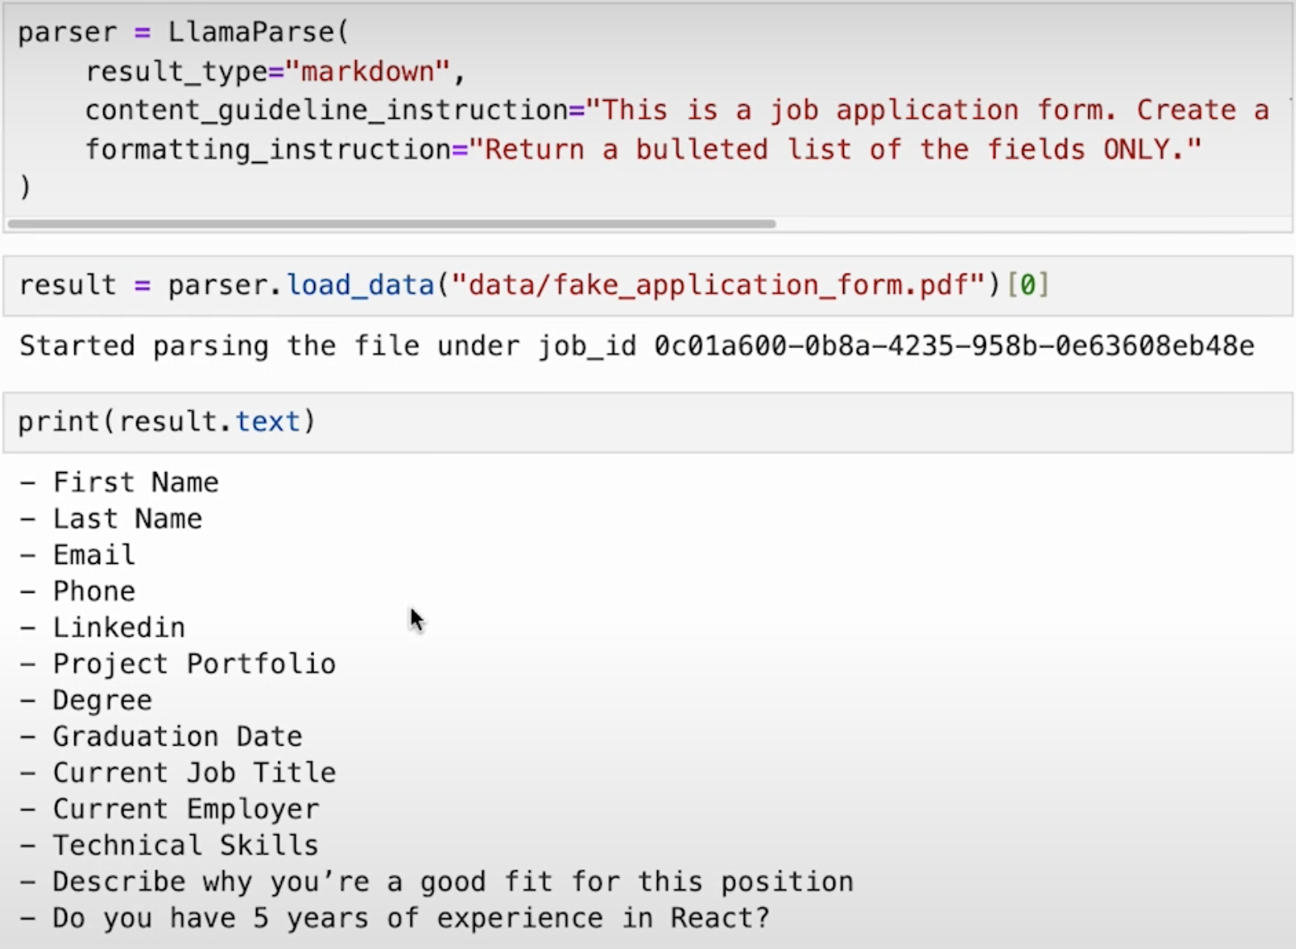

Step 2: Turn human readable formats into machine readable ones using LLM

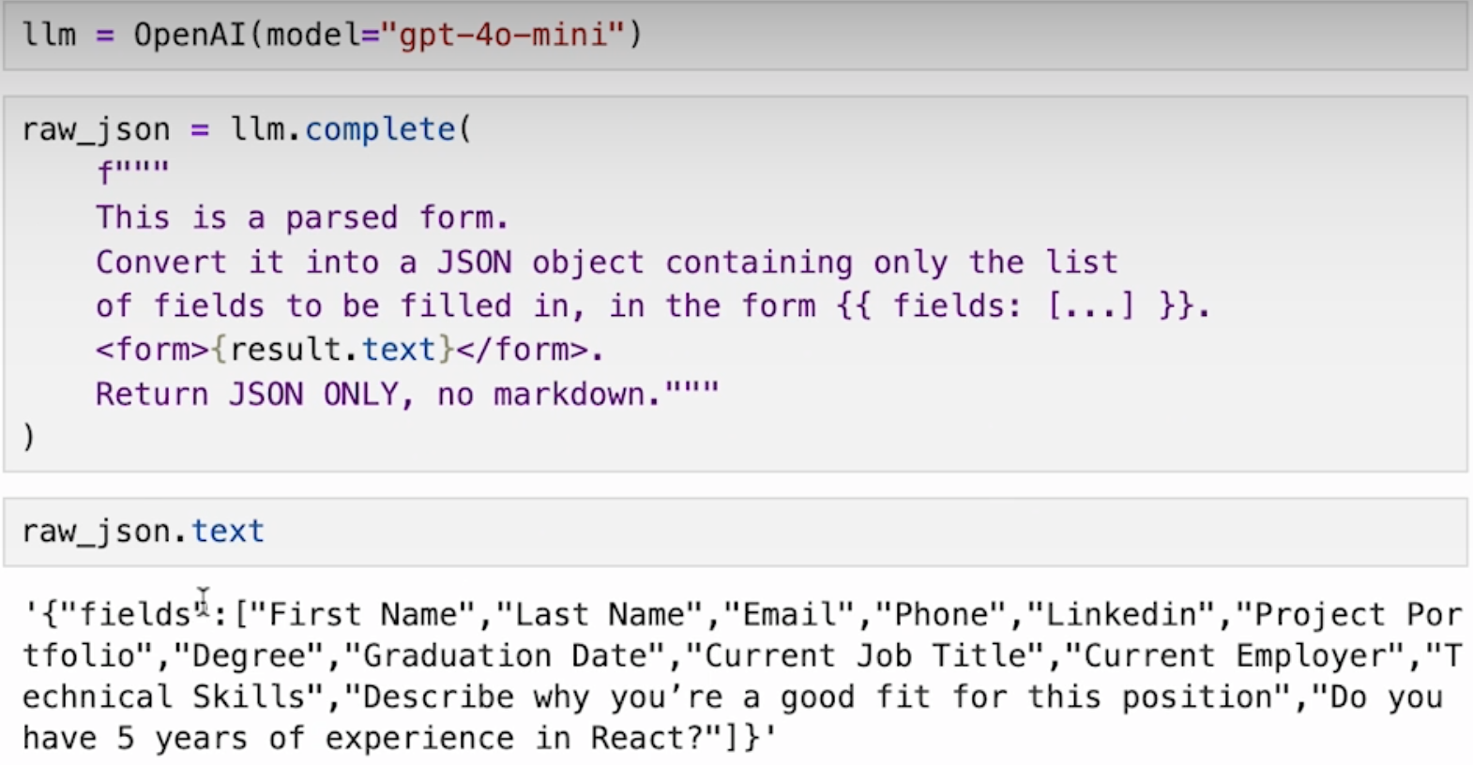

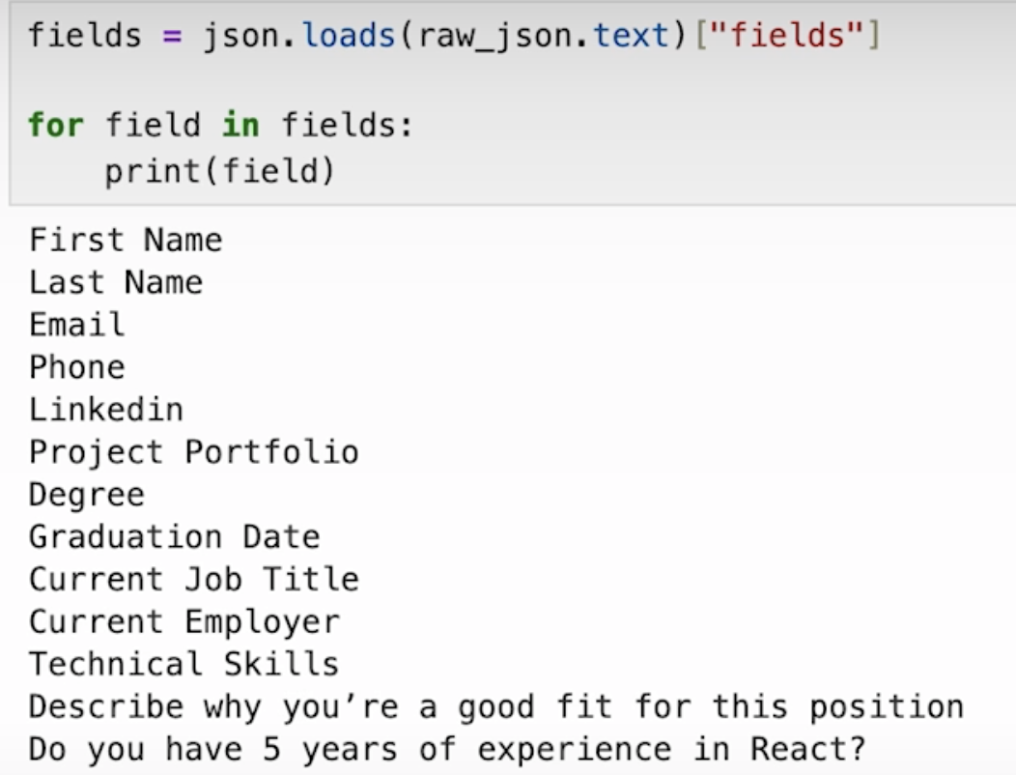

Step 3: build a workflow

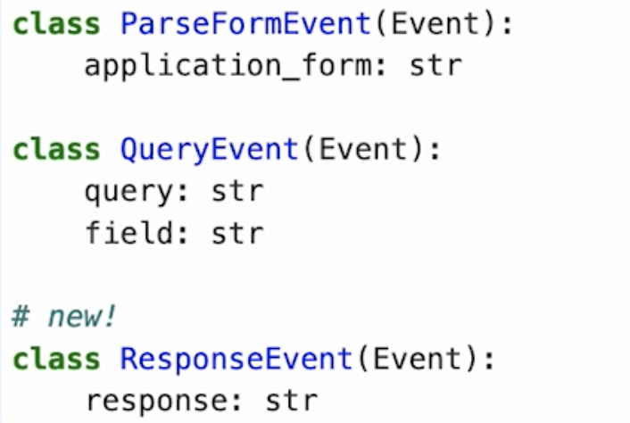

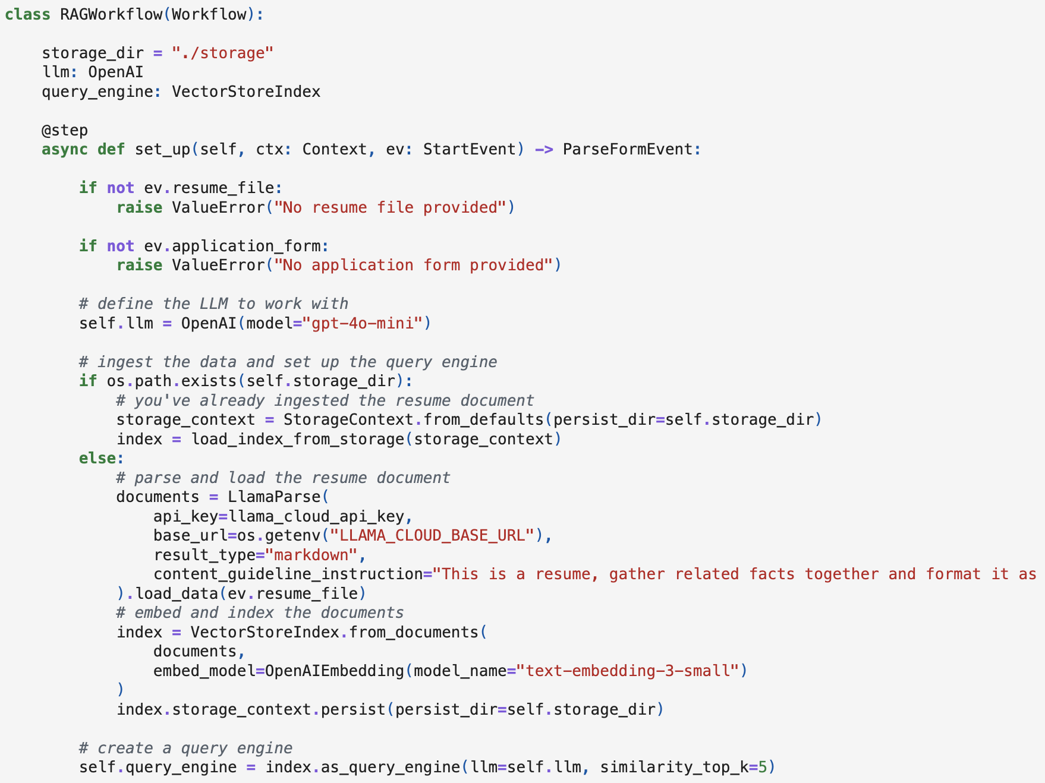

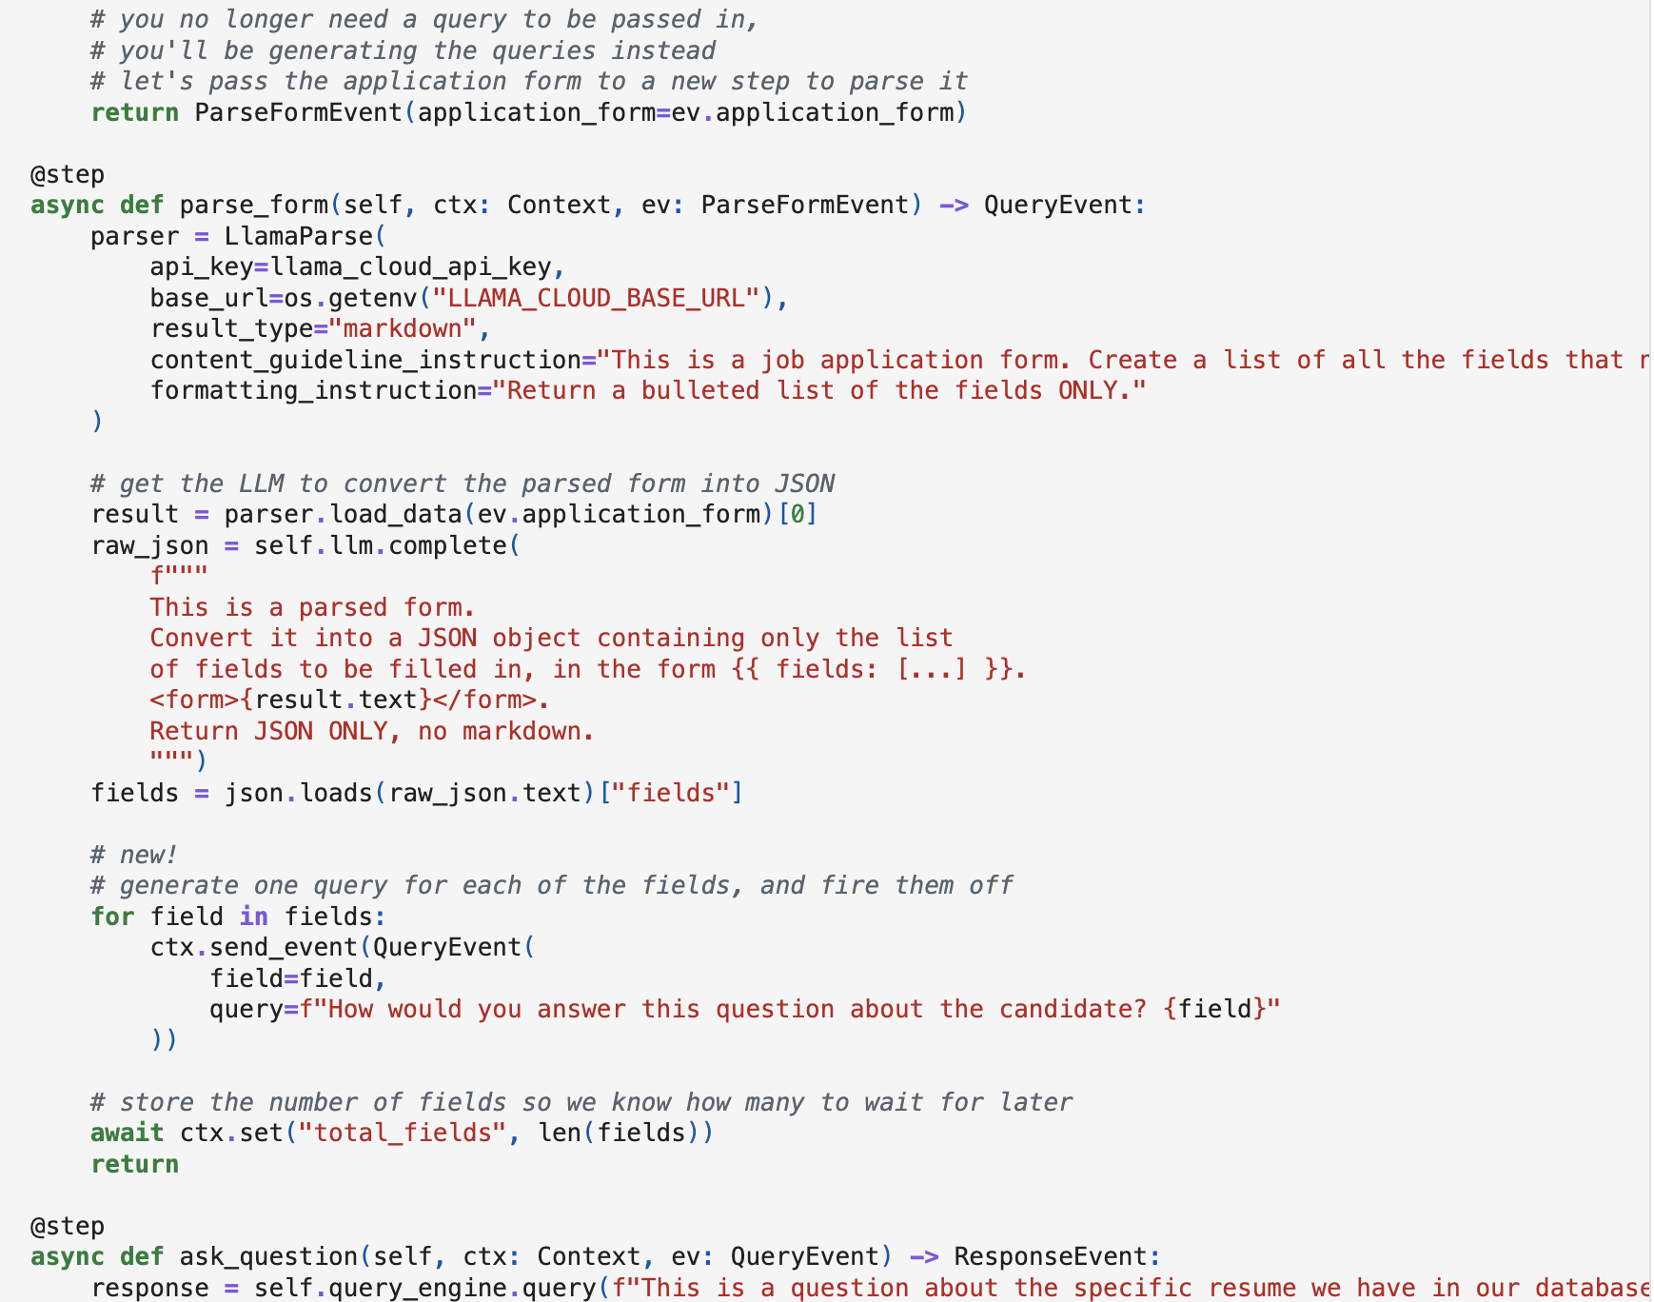

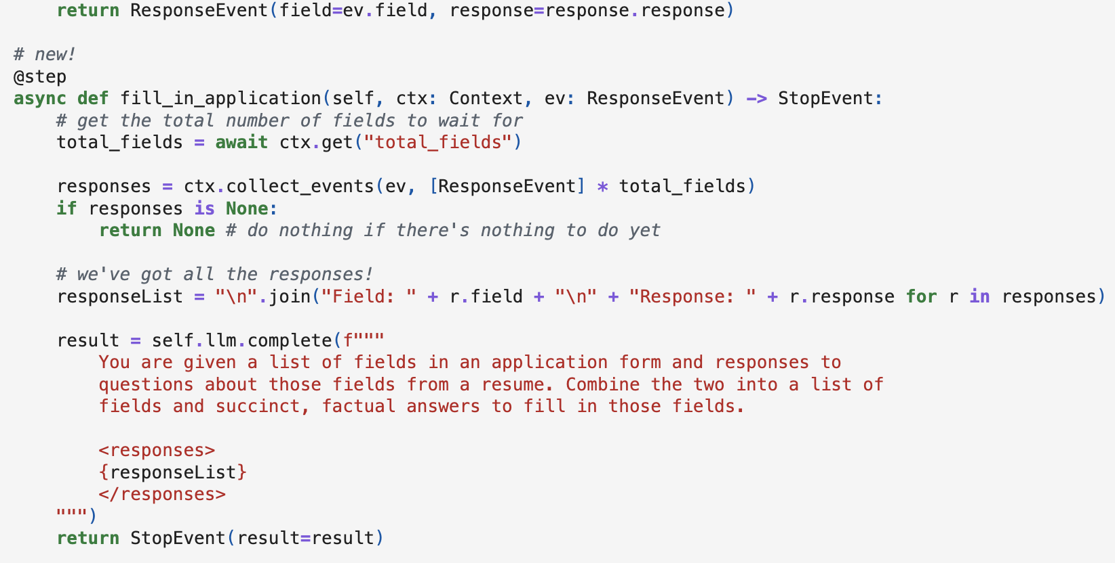

Run the workflow

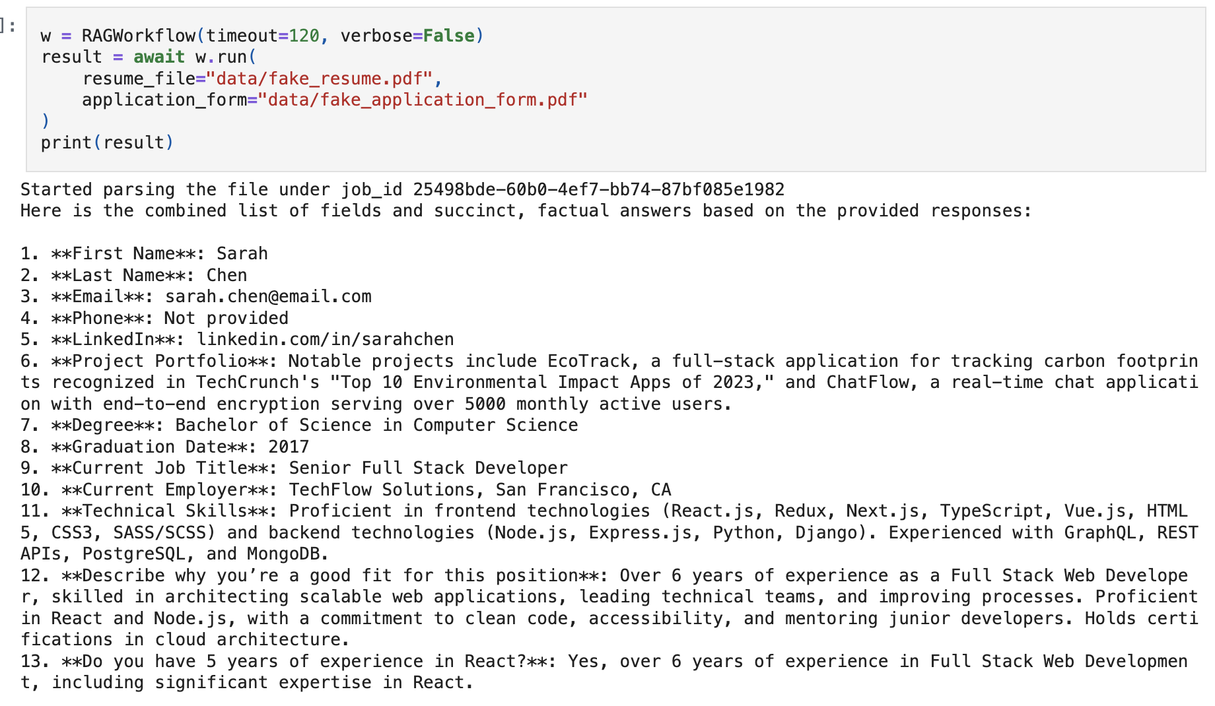

# Human in the loop

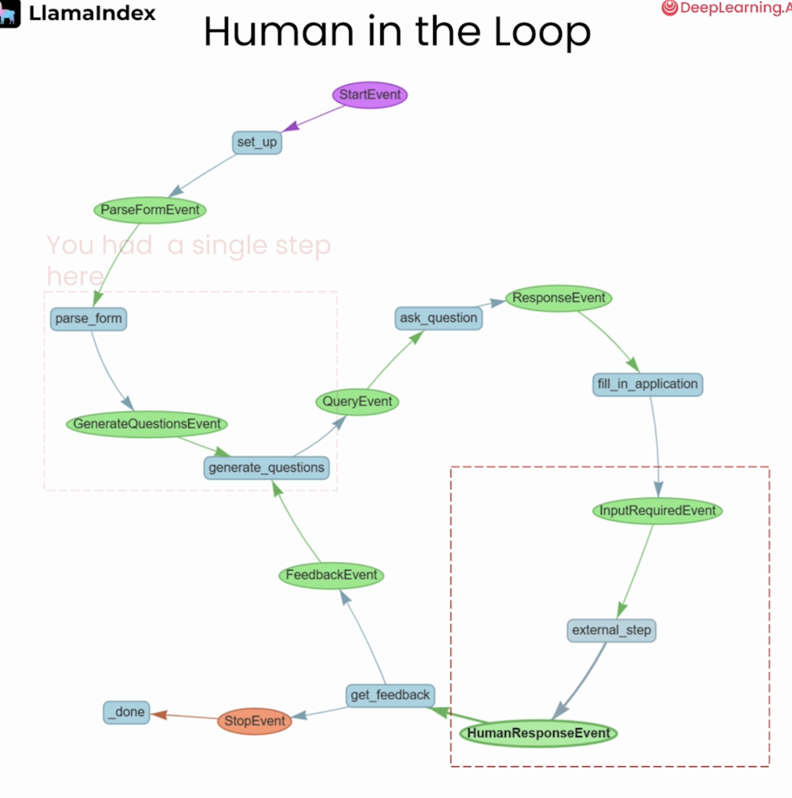

Add human feedback event

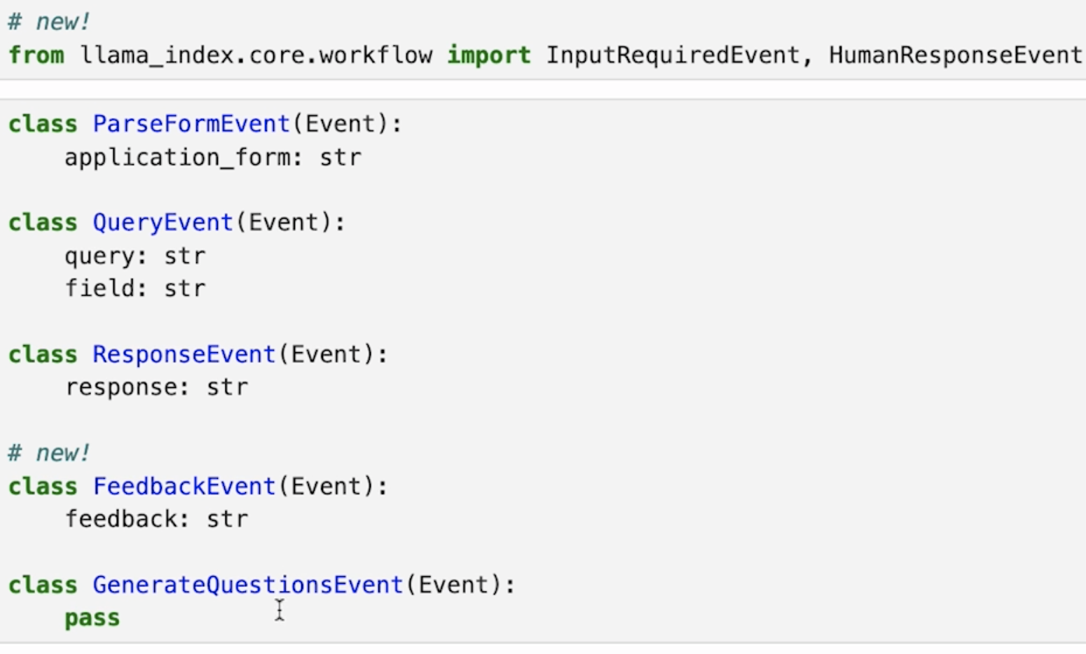

In the fill_in_application event, we emit an InputRequiredEvent

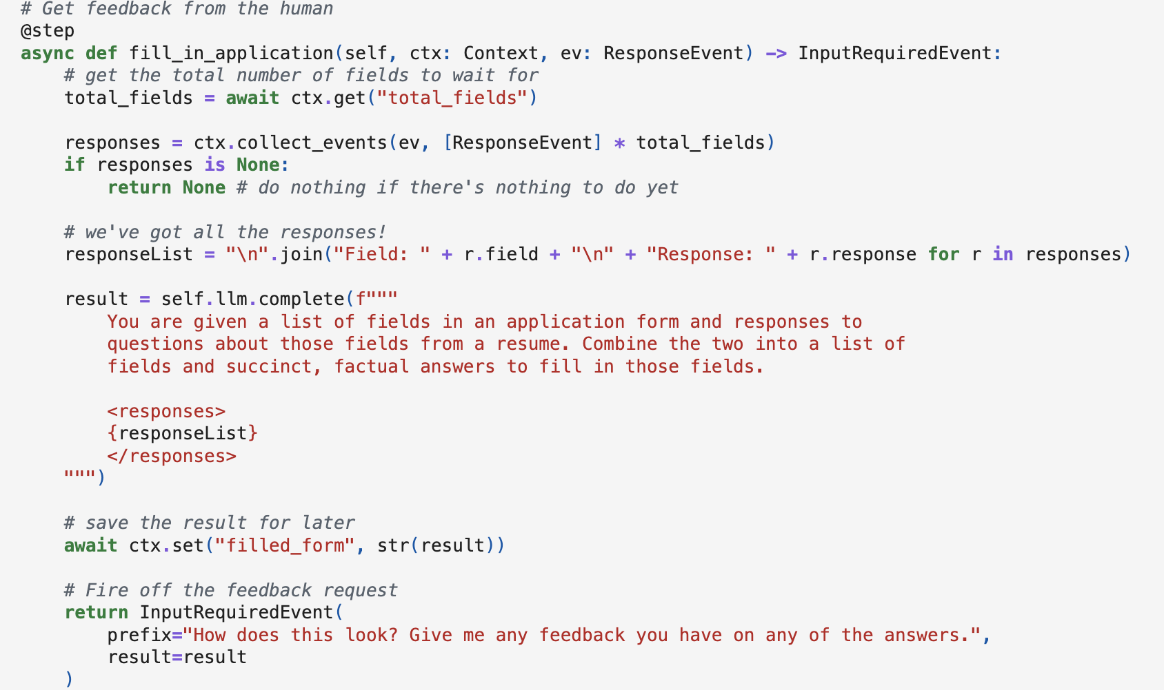

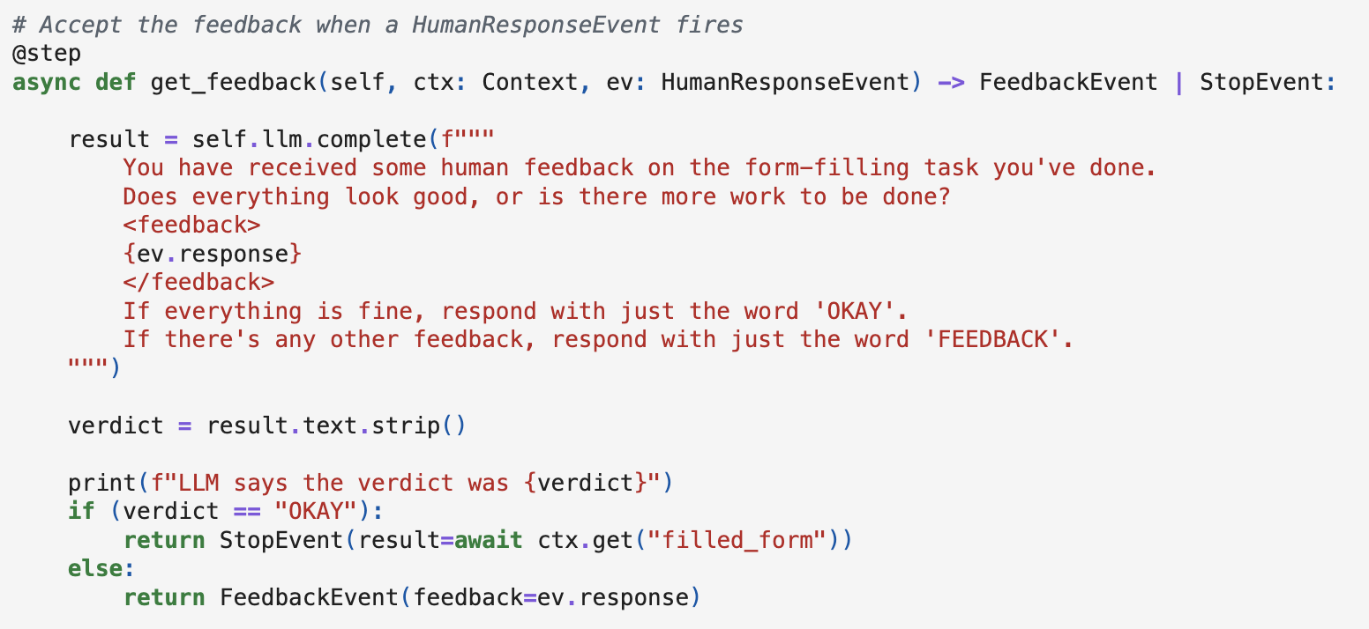

How to make the workflow understand what to do with the feedback: If there is a feedback, then append the feedback to the question

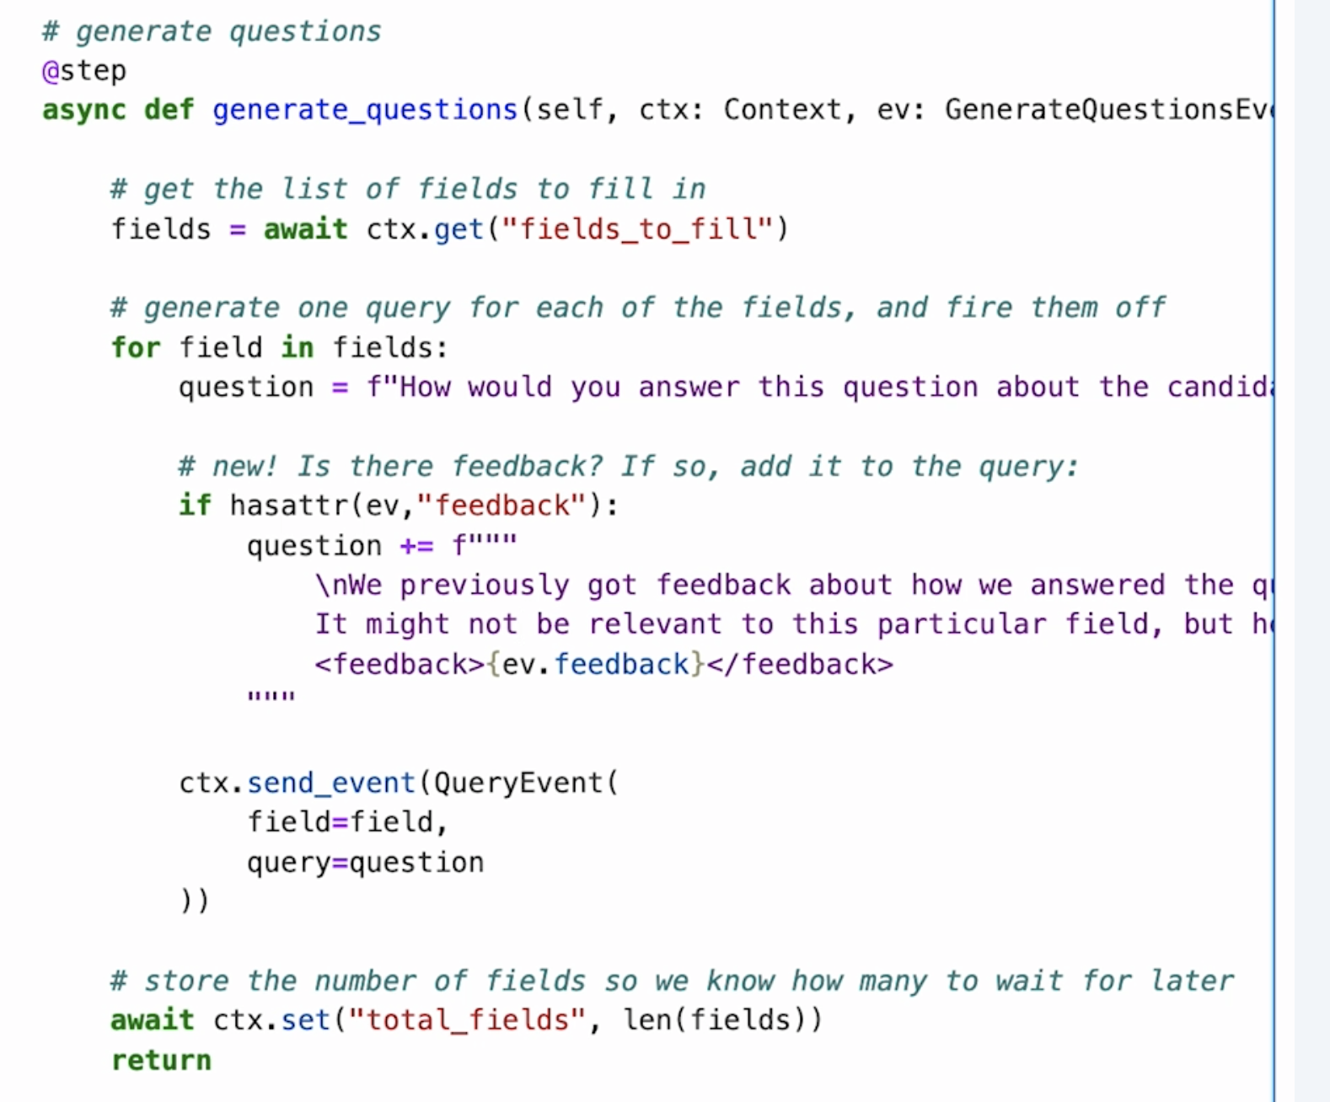

How it performs with a feedback: portfolio should be a URL:

Before providing feedback:

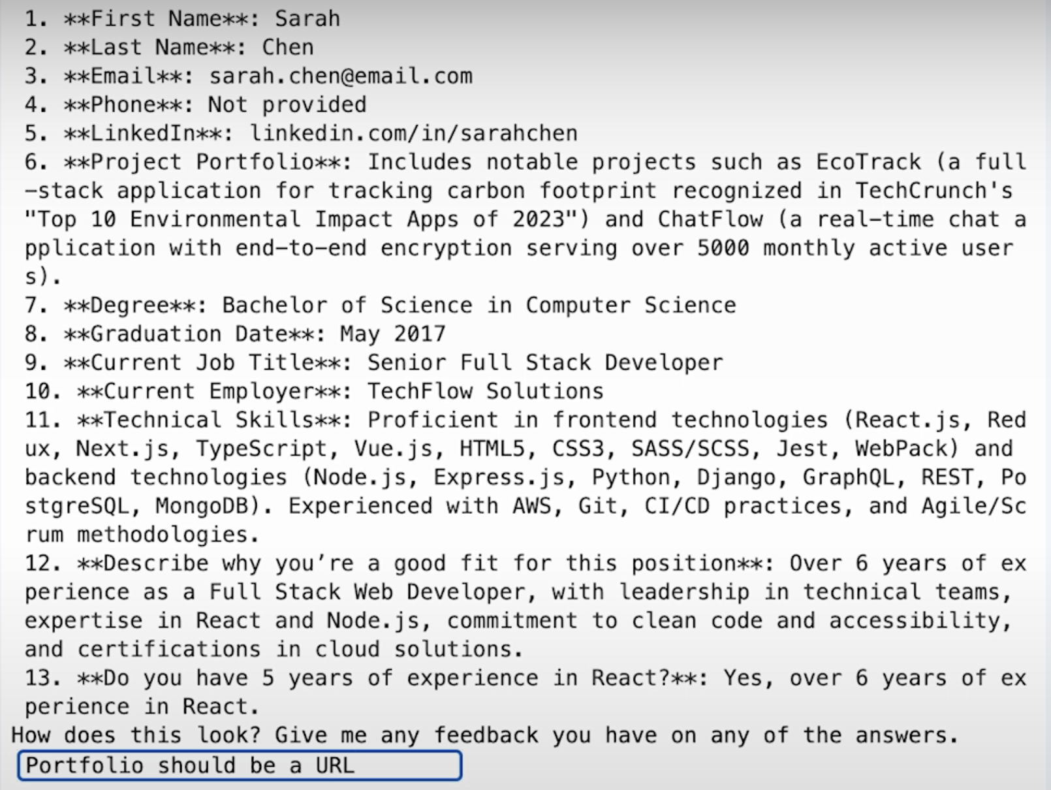

After providing feedback: it does return the portfolio with a URL

